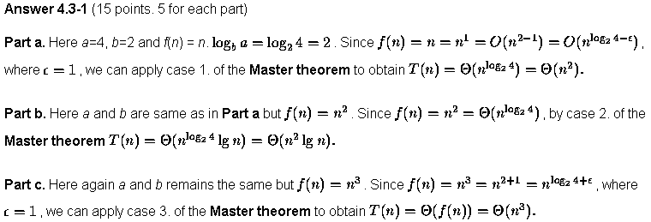

4.3-2)
For algorithm A, T(n) = 7T(n/2) + n2. Using masters theorem, T(n) = O(n ^{lg}₂ ⁷).
For Algorithm A’, T’(n) = aT’(n/4) +n2. For A’ to be asymptotically faster than T(n),
Master’s theorem case 1 should apply, and give a time complexity less than O(n ^{lg}₂ ⁷).
So T’(n) = θ(n ^{lg}₄ ª) < O(n ^{lg}₂ ⁷). Or a < 4^{lg7} or a < 4^{2.81}.

Which implies that a <= 49.

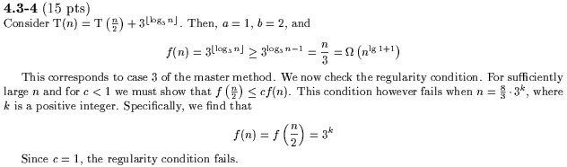

4-1)
Use Masters theorem to solve (a –f)
a) T(n) = Θ(n³ )
b) T(n) = Θ(n)
c) T(n) = Θ(n² lgn)
d) T(n) = Θ(n² )
e) T(n) = Θ(n^{lg7} )
f) T(n) = Θ(√n lgn)
g) T(n) = n + T(n-1)
= n + (n-1) + T(n-2)
= n + (n-1) + (n-2) + ……..+ 2 + T(1)
= n + (n-1) + (n-2) + ……..+ 2 + + Θ(1)
= n(n+1)/2 – 1 + Θ(1)
= Θ(n ²)
h) This was solved using change of variables. T(n) = Θ(lglgn)

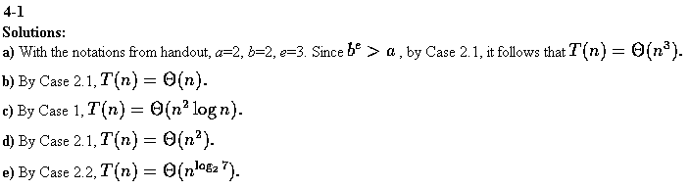

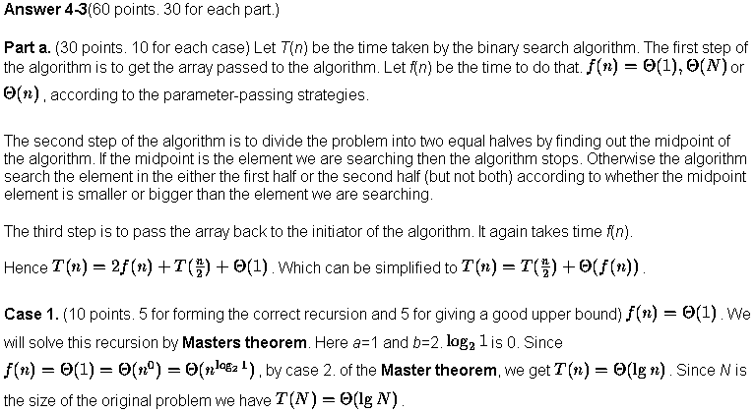
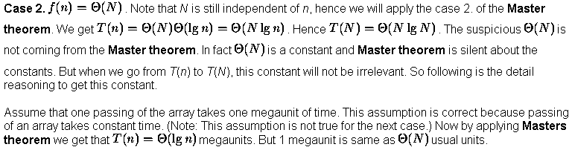
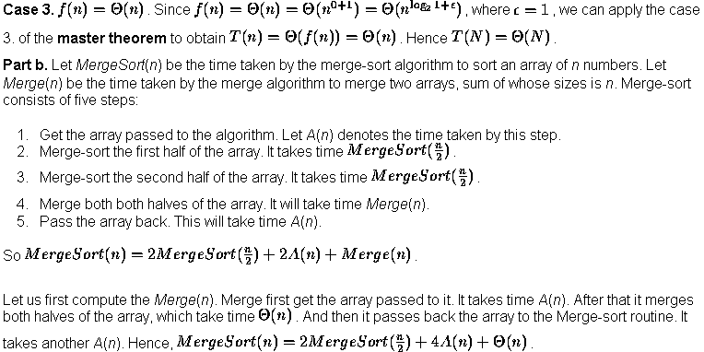
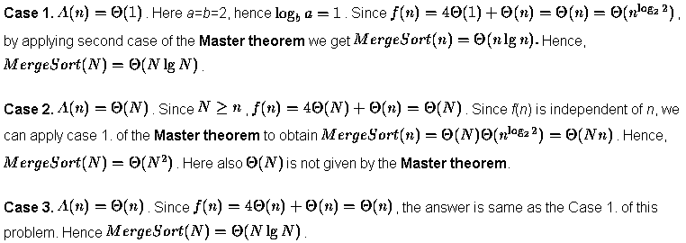

4-4)
a)
T(n)=3T(n/2) + n lg n
a=3, b=2, f(n)= n lg n
since n lg n = O(n ^{lg}₂ ³), using case 1 of the masters theorem T(n)= Θ(n ^{lg}₂ ³).

b)
T(n)=3T(n/3 + 5) + n/2
Use the substitution method, guess that the solution is T(n)= O(n lg n).
We need to prove T(n) <=cn lg n for some c and all n > n₀.
Substitute c(n/3 + 5)lg(n/3 + 5) for T(n/3 + 5) in the recurrence..
T(n) <= 3*c(n/3 + 5)*( lg (n/3+5)) + n/2.
If we take n₀ as 15, then for all n>n₀, n/3+5 <= 2n/3 , so
T(n) <= (cn+15c)*(lg n/3 + lg 2) + n/2
<= cn lg n - cn lg3 +15clg n –15c lg 3 + cn + 15c + n/2
<= cn lg n - ( cn(lg 3 –1) –n/2 – 15c lg n +15c(lg 3 –1)
<=cn lg n , by choosing an appropriately large constant c

which implies T(n) = O(nlg n)

Similarly, by guessing T(n) >= c₁nlgn for some c₁ and all n>n₀ and substituting in the recurrence we get,

T(n) >= c₁n lg n – c₁n lg 3 + 15c₁lg n – 15c₁lg3 + c₁n + 15c₁ + n/2
>= c₁nlg n + n/2 + c₁n(1 – lg 3) + 15c₁ + 15c₁(lg n – lg3)
>= c₁nlg n + n(0.5 + c₁(1 – lg 3) + 15c₁ + 15c₁(lg n –lg 3)
>= c₁nlg n, by choosing an appropriately small constant c₁ (say c₁ = 0.01) and for all n > 3

which implies T(n) = Ω(nlg n)

Thus, T(n)=θ(nlg n)

c)
T(n) = 2T(n/2) + n/lg n . Use iteration.
= 4T(n/4) + n/lg(n/2) + n/lg n = 8T(n/8) + n/lg(n/4) + n/lg(n/2) + n/lg n
= 2^{k}T(n/2^{k}) + n/lg(n/2^{k-1}) + n/lg(n/2^{k-2}) ….+ n/lg n
= n*T(1) + n/lg 2 + n/lg 4 + n/lg 8 …. + n/lg n) (when 2^{k}=n)
= cn + n(1/lg 2 + 1/lg 4 + 1/lg 8 + …1/lg n)
= cn + n(1/1 + 1/2 + 1/3 + …1/lg n) = cn + nlg(lg n) = θ(nlg(lg n))

d)
T(n) = T(n-1) +1/n . Use iteration
= T(n-2) +1/n-1 + 1/n = T(n-3) +1/n-2 + 1/n-1 + 1/n ..= T(1) + 1/2 +1/3 +1/4..+ 1/n-1 +1/n
= c + lg n = Θ (lg n)

e)
T(n) = T(n-1) + lg n. Use iteration.
= T(n-2) +lg (n-1) + lg n = T(n-3) + lg(n-2) +lg(n-1) +lg n ..= T(1) +lg 2 +lg 3 ..+lg(n-1)
+lg(n) = c + lg(n!) = Θ (nlg n)

f)
T(n) = √n T(√n) + n. Use a change of variables, n = 2^{m} .
T(2^{m}) = 2^{m/2} T(2^{m/2} ) + 2^{m/2} . Let S(m) = T(2^{m}), then S(m) = 2^{m/2} S(m/2 ) + 2^{m} .
Using iteration, S(m) = 2^{m/2} (2^{m/4} S(m/4) + 2^{m/2} ) + 2^{m/2} = 2^{3m/4} S(m/4) + 2*2^{m}
= 2^{3m/4} (2^{m/8} S(m/8) + 2^{m/4} ) + 2*2^{m} = 2^{7m/8} S(m/8) + 3*2^{m}
….. = 2^((2^{x} – 1)*m/2^{x} ) S(m/2^{x}) + x*2^{m}
when 2^{x} = m, S(m) = 2^{m-1} S(1) + lg m*2^{m}
or T(n) = n/2 * T(2) + n lg(lg n) = Θ(n lg(lg n)).

4-7)
a)
To find out whether a chip is good or bad by pairwise testing, we can test it against the remaining chips and see whether the other chips say that this chip is good or bad. In case more than half of the chips are good, then depending on what the majority of the chips in the pairwise tests say about this chip, we can proclaim the chip to be either good or bad. However if more than half of the other chips are bad, then we cannot go by what the majority of the pairwise tests say, and so cannot determine whether the chip is good or bad.

b)
Suppose you have a set C of n chips of which more than n/2 are good. Make n/2 pairs of adjacent chips and test them against each other in the pairs. Take all the pairs which give a (good,good) output. Let these pairs be x in number. These pairs are either {good,good} chips or {bad,bad} chips. We can claim that at least half of these x pairs will consist of {good, good} chips. This is because if less than x/2 pairs are {good,good} chips, we get more than x/2 {bad,bad} chips, which mean more than x bad chips; Plus n/2-x other output pairs ( {like bad, bad}, {good, bad} or {bad,good} ) which have at least one bad chip in those pairs. So we have greater than x + (n/2-x) bad chips or greater than n/2 bad chips, which is contradictory to our assumptions.
So our claim that in our x (good,good) pairs there are at least x/2 actual {good,good} chips, is verified. Take one chip from each of these x pairs, and create a new set of chips S. Now the number of elements of S is less than n/2, since its equal to x and x<n/2. Also more than half of these x chips are good, because of our claim that in our x (good,good) pairs there are at least x/2 actual {good,good} chips. So we have effectively reduced the initial problem of set C into a problem of set S of less than half the initial size.

c)
From the earlier part, we can express the problem of finding one good chip among n chips into a recursive algorithm by reducing the problem into a problem of size < n/2. The number of tests to do this is O(n). So the recursive equation for the total number of tests is:
T(n) = T(x) + O(n), where x is the number of {good,good} outputs. Since x <n/2,
We get T(n) < T(n/2) + O(n). Solving this by assuming an equality sign instead of a less-than sign, to get an upper bound, we obtain T(n) = O(n).

